**Business Plan**

NoQ

Group 09

Lim Wen Qing A0142254N  
Nicholas Foo Zi Hao A0139715Y  
Thng Kai Ting Brenda A0143035U  
Yong Zhun Hung A0138922B

# 

# Table of Contents

1. Executive Summary

2. Business Description

3. Value Proposition

3.1 For Consumers

3.2 For Vendors

4. Revenue Model

4.1 Advertising Revenue Model

4.1.1 Google AdSense

4.1.2 Cost-Per-Click Featured Listing

4.2 Commission Model

4.3 Set-up Fees

5. Market Opportunity

5.1 Current Business Environment

5.2 Market Analysis S.W.O.T Analysis

5.3 Customer Profile

5.4.1 Consumers

5.4.2 Vendors

5.4 Market Size, Sales & Share Projections

5.5 Sales Strategy

5.5.1 Customer Referral

5.5.2 Vendor Referral

6. Competitive Environment

6.1 Indirect Competitors

6.2 Direct Competitors

6.3 Regulatory Elements

6.4 Social & Technological Trends

7. Competitive Advantage

7.1 Advantage over Direct Competitors

7.2 Advantage over Indirect Competitors

8. Marketing and Advertising

8.1 Road Shows

8.2 Referral Programme

8.3 Trial and Demo Requests

8.4 Other publicity stunts

9. Mockup Mobile Appliction

10. Database

11. Conclusion

12. Future Plans

12.1 Accuracy of Waiting Time

12. 2 Expand to Restuarants

12. 3 Wireless Top-Up Services

12. 4 Collaborations with other industry related businesses

References

# 2. **Executive S**u**mmary**

NoQ is an app designed to redefine the way we order our food. Through an online system, NoQ diminishes queues and improves the overall efficiency of food vendors. By moving physical lines to online queues, it saves users the pain and time spent standing in line to purchase their meals. This not only changes the way we order our food, it would also benefit time-saving users looking to grab their meals as quick as possible by allowing them to purchase their meals without having to physically wait in line.

With the increasing popularity of M-Commerce apps and the rising numbers of smartphone penetration in Singapore, NoQ is targetted at vendors, students, and staff on campus. Also, there is a rising popularity of queue management systems among vendors and food ordering services among consumers, and NoQ provides a one-stop solution by combining both types of services into one platform.

The process of ordering from NoQ is a fuss free one, as users need simply to download the free application and top up their credit balance at various kiosks. Once done, users get to browse throw the various food items that vendors are selling. After purchasing their order, they will be notified about the approximate waiting time. Finally, once it hits collection time, the user need only to open their application and show them their unique QR code for redemption.

For vendors, only a one time set up fee is required to get them the latest installation of NoQ as well as a vendor-specific version of the NoQ app which can be used for recieving of meal orders, scanning of QR codes as well recording meal orders. All the data from their order will also be processed through data analytics to provide vendors with greater insight of their business plan.

To effectively promote our application, we plan to undertake various marketing schemes such as road shows, trial versions, cross advertising and having a referral system which would be further explained later on in the business plan.

Although it may take time for our relatively new system to be fully accepted by both vendors and consumers, we have confidence that NoQ will be revolutionary in its ability to provide greater convenience for all the different stages of food ordering.

As our business grows, we aim to expand NoQ locally to other restaurants and eating areas, though collaboration with other similar businesses. If we succeed locally, we could even expand our brand internationally. NoQ envisions to be the go-to app for both consumers and vendors when it comes to the ordering of food. Ultimately, our aim as a measure of success is to become a brand associated with quality services for the modern-day dining experience.

# 2. Business Description

Often times, during lunch hours, queues in food canteens can get really long. More often than not, many individuals under time constraint ranging from students rushing in between classes to working adults churning out work may not even have the time to queue up to purchase their meals. With the help of NoQ, individuals can purchase their food from various foodstores with their mobile devices. Customers are given estimated waiting times thus informing users on when to collect their food, eliminating the need to even physically queue at all as NoQ “brings” the queue to them revolutionising tradional queues.

# 3. Value Proposition

NoQ’s various features allows both consumers and vendors to enjoy benefits that they otherwise would not receive with the traditional queueing system.

## 3.1 For Consumers

NoQ replaces the idea of the physical queue, where instead of being physically present to queue for their meals, customers can now do it at their fingertips anywhere and anytime. Consumers can save the time spent waiting in queue, and it also eliminates the need for cash transactions as payment is done through their NoQ account’s stored credits. This is ideal for students who have limited time for lunch break and for school staffs who wish to maximise their lunch break. Also, NoQ’s stall ranking system and Quick Buy services helps consumers to decide on their order and place their orders instantly.

## 3.2 For Vendors

Vendors save time and manpower as they no longer need to handle cash transactions or look for change with NoQ’s credit payment system. With our ranking system, vendors stand a chance to be listed as one of the top stalls, giving them greater publicity which could help boost sales. NoQ also provides sales report and analytics at the end of every month to the vendors, and vendors will no longer have to manually record sales. Also, our sales analytics will empower vendors to estimate how much resources are needed for the upcoming lunch period or even the following month.

# 4. Revenue Model

NoQ generally utilises 2 revenue models, the Advertising Revenue Model and the Commission Model. For models that require vendors to pay to us, the amount due for payment is accumulated and deducted from the vendor’s final earnings that NoQ pays to vendors every fortnight.

## 4.1 Advertising Revenue Model

### 4.1.1 Google AdSense

Pay-per-click advertising through Google AdSense can help us generate revenue with the right keyword choices. Relevant ads are generated by AdSense based on the content of our application, and Google chooses which the Ads to place on our app based on the keywords we have on our app. With the use of Google AdWords Keyword Planner, we have compiled the Top 20 keywords related to our business, according to their suggested bids. By using keywords from this list in our app, it could help us maximize our revenue generated from Google AdSense.

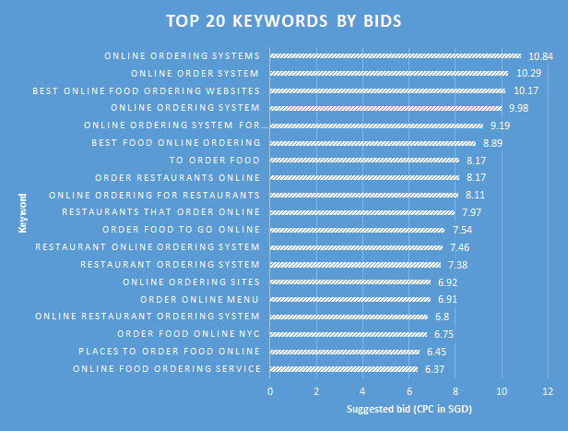  
*Figure 3.1 - List of top 20 Keywords related to our services by suggested bid, as generated from Google Adwords’ Keyword Planner tool*

### 4.1.2 Cost-Per-Unique-Click Featured Listing

Vendors can pay to be featured on the rankings page based on a cost-per-unique-click system, at a cost of $0.10 per unique click. This means that everytime a unique user clicks on their stall listing on the rankings page, the vendor will be charged $0.10. The price is relatively low for vendors to consider opting for this method of publicity, and it also comes at no cost to us. Also, as our business grows, the traffic on our rankings page will also increase, and more people will click on the featured listing, bringing us greater revenue.

## 4.2 Commission Model

As our services brings greater publicity and convenience to vendors, we could charge vendors a commission fee of 3% of their sales revenue. In other words, we will deduct 3% of total sales made from the vendors. Revenue from commission fees scales as more consumers use our app, and also reflects a growth in the sales of our vendors. This is a win-win situation as an increase in our commission revenue would mean that there was an increase in sales for vendors. While other food listing businesses have been known to charge 5-15% for commission, our commission fee is relatively lower as our vendors are school hawkers whose food prices are at student prices as compared to high-end restaurants that are featured in the other businesses. (Seward 2016) Setting our commission fee at a lower rate and using such a success-based model ensures that vendors will not be deterred by the extra costs and willing to experiment with us.

## 4.3 Set-up Fees

Vendors are charged a one-time set-up fee of $50 for services which includes loaning of a NoQ tablet, helping them set-up infrastructure requirements (i.e. Two top-up kiosks per location) and training them on usage of NoQ system. Although this will only make up a small portion of our revenue, it is necessary to cover the costs of setting up the relevant equipment needed for a canteen to operate with the help of our services. Additional funds required will be funded by the grant from PIC.

## 4.4 Protecting vendors’ rights

In order to protect the rights of food stalls under NoQ, a non refund policy would be imposed so as to prevent customers from backing out last minnute and thus wasting stall owners’ resources. Users who have ordered their food are entitiled to a 100% refund if they were to cancel their orders more than 15 mins away from the collection time. If collection time is 15 mins(or lesser) away and users were to choose to cancel their order, there would be no refund and the transaction would still go through. Hence, ensuring nonrepudiation.

# 5. **Market** Opportunity

Marketing is key to the success of this business. The company’s operations will center around the marketing and brand image plans. Through our marketing, we will strive to be visible. This will be accomplished by investing in our image and building equity in it. The company will set standards which will be adhered to, through these standards the company will become credible. Becoming visible and credible are the two main goals of our marketing plan.

## 5.1 Current Business Environment

Currently, food stalls operate with the presence of physical queues. Attempts were made to increase the effieciency of waiting by the likes of TickTok where consumers get a rough estimates of waiting times and leave their phone numbers and get notified when it is their turn. However these were mostly found in restaurants and cafes but not at food stalls of canteens. Hence at the moment, there is an opportunity for a further improved system in canteens for the benefit of time conscious individuals where time is of the essence.

## 5.2 ***Market Analys***is S.W.O.T Analysis

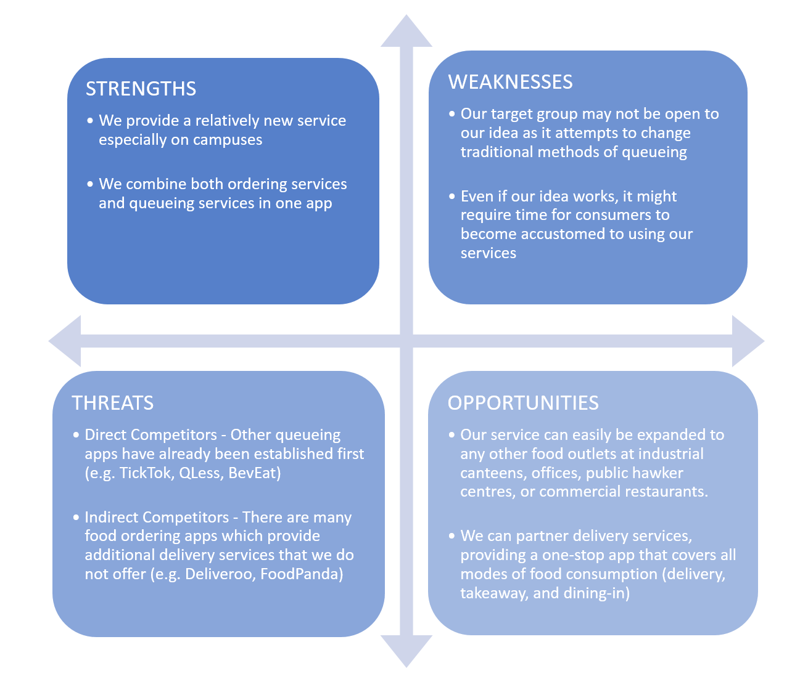

## 5.3 ***Customer Profile***

### 5.4.1 Consumers

Our main target audience are time conscious consumers who would use NoQ as a way of helping them to maximise time. Hence, we have chosen students and school staffs who often do not have a fixed schedule and find themselves short of time during breaks. Also, as students are known to be more tech-savvy, they are ideal target consumers as they are more likely to make use of our app than consumers of other age groups.

### 5.4.2 Vendors

In general, we are looking to partner vendors with stalls situated in educational instituitions or office buildings where a higher demographic of customers are those that wish to save more time. As vendors are mostly small businesses, they are more likely to use our services as a simple solution to curb manpower shortage or simply improve the efficiency of their operations.

Of course, our ultimate goal is to redefine traditional queueing systems and to deliver the NoQ experience to various food courts.

## 5.4 ***Market Size, Sales & Share Projections***

The market size of the food industry is large and oppotunities are abundant. Since food is a neccessity, there would be a large opportunity of growth if there is a rising damand for NoQ as it can be installed in many food places. Our market share growth would thus be limited by our market demand as well as the ability of our system and database to handle a higher consumer base.

In terms of direct competitors, there have not been such similar applications that are currently exisiting in the market as of now. It is nevertheless worth noting that there is a school project, BevEat, that can be a potential direct competitor to NoQ have set up an app. However, they are still in the developmental stages of their installment. BevEat’s appliation for iOS was first started on 26 Novemer 2015. Their Android version was started on 18 July 2015 and has recently added pre-ordering functions into their app in version 1.5 (launched on 28 January 2016) with a total number of installs of 100-500 (Google 2016). As a result, similar applications do not actually have a very strong placing in the local market as of yet.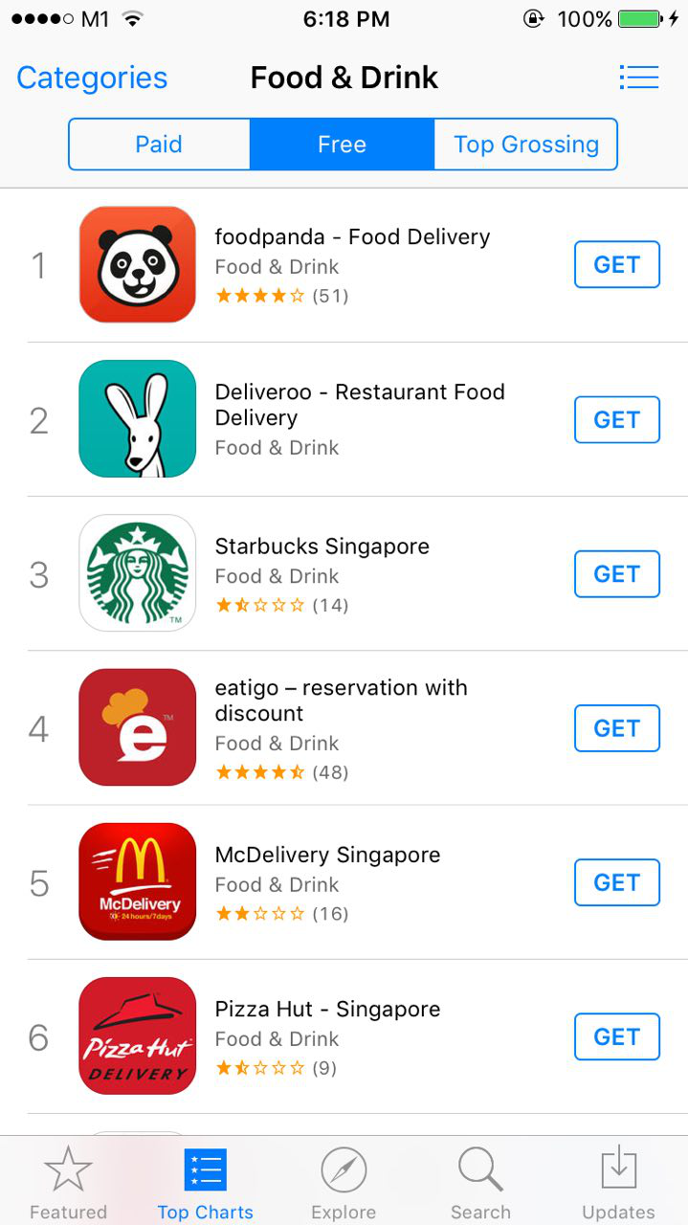

Our indirect competitors, in particular delivery food applications such as FoodPanda as well as Deliveroo, are fairly well established. Deliveroo is ranked 2nd in the local Apple App Store under the Food & Drink category while FoodPanda is ranked 1st in the local Apple App Store. Needless to say, the market for our indirect competitors are dominated by many dominant players.

However, due to Apple’s privacy settings, we were unable to obtain extensive information about user downloads for applications not owned by us. Also, many application analytics websites require us to subscribe to a premium service before accessing even greater and in depth data.

In sum, the market presents various opportunities for us to venture into, seeing that there are only a handful of apps that offer almost similar functions as us. Indirect competitors such as FoodPanda and Deliveroo may be dominating the market, however, NoQ’s target audience differs slightly and hence it can be argued there is a space in the market for NoQ.

## 5.5 ***S***ales Strategy

In order to ensure the success of NoQ, we have come up with several sales strategies to sell our business idea to both consumers and vendors, and to ensure that they continue using our application as repeat customers.

### 5.5.1 Customer Referral

Our primary method of gaining new customers would be the use of a referral system. Each user would have their own “referral code” which they can use to refer new users. Upon successful registration, both of users(i.e referrer and referee) will get $3 worth of NoQ credits added into their account. This provides an incentive for existing users to share about NoQ and encourages new signups.

### 5.5.2 Vendor Referral

Our business will only work with the partnership of vendors. In order to obtain more sign-ups from new vendors, the referral system could also work on vendors, where vendors are entitled to a partial refund of their set-up fee if they successfully refer another vendor to sign up for our services. This encourages existing vendors to participate in the referral programme, and also attracts new vendors to sign up for NoQ.

### 5.5.3 Seasonal Discounts

Additional efforts to retain consumers and ensure repeat orders include offering seasonal disounts, such as Back-to-School or exam period discounts. We could also offer free additional credits in their credit accounts. This will encourage customers to use our app during these time periods, especially during these periods students and staff would be busier than usual. Periodical discounts ensure that consumers will constantly hear from our brand and be inclined to place orders through our app.

# 6. Competitive Environment

## 6.1 Indirect Competitors

Various delivery applications such as Deliveroo as well as FoodPanda can be considered indirect competitors to us as they are similar types of business vying for the same consumer dollar. As they provide delivery services, consumers may find it more convenient to opt for delivery through their applications instead of using our services where they still need to be physically present to collect their order.

## 6.2 Direct Competitors

We face competitions from local companies such as TickTok as well as international companies like QLess. Both companies bear similarity to us as they allow customers to queue virtually. However, they require their consumers to be physically present at the stall to leave their contact numbers before commencing their virtual queue. In contrast, NoQ removes the need for this additional step as it allows customers to start “queuing” as they place their order through the app, allowing them to recieve their orders at the stalls without having to queue physically beforehand.

## 6.3 Regulatory Elements

As a business operating in Singapore, we are required to adhere to the Personal Data Protection Act (PDPA). This means that as we collect client (both consumers and vendors) information, we need to ensure that they are aware and have agreed to disclose the information to us. Also, we need to ensure that the information receive remain secure and will not be exposed to security or privacy threats.

NoQ is also eligible for the claiming of additional cash as The Inland Revenue Authority Of Singapore (IRAS) has newly revised their Productivity and Innovation Credit Scheme (PIC), a scheme designed to encourage productivity and innovation activites in Singapore. (“Productivity and Innovation Credit Scheme - IRAS” 2016) We can claim additional funds under the qualifying activity of Acquisition and Leasing of PIC IT and Automation Equipment. These funds will be used to purchase our top-up kiosk and other equipment needed for NoQ to be fully operational in any canteen. However, we need to ensure that our business fulfills the requirements of the claim, one of which includes the condition that our “business unit requires at least 3 local employees”.

## 6.4 Social & Technological Trends

According to research, Singapore is ranked highest globally for smartphone penetration with 9 out of 10 respondents having access to a smartphone.(Smartphone penetration in Singapore the highest globally: Survey 2016) With a growing number of mobile users in Singapore, it would provide further incentive for us to make everyday activities such as consumption of meals more accessible to users.(“Google study: Singapore is world’s top smartphone market per capital - Mumbrella Asia” 2014) Hence, this rising trend favours NoQ in creating a mobile platform for users to “queue” and pay for their food and collect them without having to waste time waiting.

It was recently reported that there has been an increasing popularity of food delivery services, which could mean greater competition for us. (“More players jumping on the food delivery wagon” 2016) However, our target group is differs slightly from that of the delivery services. The popularity of these services could mean that consumers and vendors will be more open to using our new services. For instance, vendors who already partner FoodPanda could be more inclined to partner NoQ as both apps will boost their sales from a different set of consumers. Similarly, consumers who are used to ordering delivery through apps may also be more inclined to opt for online ordering of their food through NoQ.

# 7. Competitive Advantage

NoQ integrates both queueing services and food ordering services that our direct and indirect competitors provide. As a result, we gain the upper hand in several aspects when compared to either our direct or indirect competitors.

## 7.1 Advantage over Direct Competitors

While NoQ allows consumers to place their order in advance at any time and anywhere, TickTok and QLess require an additional step where consumers must be physically present before obtaining a place in the queue. Hence. NoQ saves consumers the extra time and effort spent having to go down to the stalls just to physically obtain a spot in the queue.

TickTok also does not have any payment services, whereas NoQ’s e-Wallet system brings greater efficiency for both vendors and consumers as no physical handling of fees are needed. The system of stored credits also allows for discounts and credit gifts which TickTok cannot provide, giving consumers more incentive to use NoQ instead.

Furthermore, TickTok’s queueng service sends a Short-Message-Service (SMS) notification to consumers when the queue has reached their turn and vendors have to personally call the customers to confirm their seats. NoQ does not require additional SMS platform as notifications are performed through the application nor require vendors to call the customers, instead it is being automated by the system to notify the customer when their food is ready.

Since our direct competitors merely provide queueing services, they lack the additional ordering service and e-menu that NoQ has. This additional service means that consumers can decide on their order and place their orders in advance without having to be physically present. This saves time for both vendors and consumers as vendors do not have to wait for consumers to decide on their orders, and consumers do not have to physically travel to the stall just to find out what is offered on the menu.

## 7.2 Advantage over Indirect Competitors

Competitors such as FoodPanda and Deliveroo’s payment systems require consumers to pay through their application, which means that they will need to request for consumers’ credit card information. In contrast, NoQ’s eWallet system and topup kiosk means that we do not store important credit card information. This allows for better privacy and security for consumers as they do not have to risk their such personal information from being stolen should there be a breach of security.

Another main difference between NoQ and its indirect competitors is that consumers’orders are self-collected instead of delivered. There is an option for consumers to choose whether to dine in or take away. As NoQ’s target groups are on campus, it may take more time for delivery crew to collect and deliver orders to consumers, especially since it may be difficult to orientate campus locations as compared to fixed home addresses that FoodPanda and Deliveroo deliver to. Self-collection reduces this additional waiting time as consumers can simply order as early as 45 minutes in advance.

Additionally, delivery service apps may incur delivery fees in contrast with NoQ which bears no additional cost to users.

# 8. Marketing and Advertising

In order to make our business known to our target group, we have in mind several plans to ensure that we can reach out to both consumers and vendors to make our brand known to them.

## 8.1 Road Shows

One of the fastest ways to get our business across to our target group is by physically publicizing at a place where they frequent - their campus. Road shows on campus guarantees that almost anyone who passes our booth will belong to our target group. Also, road shows allow us to physically distribute any incentives or offers for potential customers to sign up with us. For instance, we could publicize NoQ in canteens, and offer free credits to those who sign up on the spot.

## 8.2 Referral Programme

As mentioned earlier, referral programmes will encourage both consumers and vendors to sign up for NoQ’s services. As more consumers and vendors sign up and refer others to use our services, our network of consumers and vendors will grow.

## 8.3 Trial and Demo Requests

As a new start-up, vendors may be uncertain or doubtful of the difference NoQ can make for their businesses. By offering the option of a demo or a trial period, it provides us with the opportunity to showcase the merits of the services that we can offer, at the same time allowing vendors to experience the benefits of our services in reality. The offer of a demo or trial period also reflects our confidence in our services, which could help further persuade vendors to take up our services. We intend to offer 3 months commission-free trial for vendors to experiment with our system.

## 8.4 Cross-advertising partnership with Carousell

Carousell is a popular e-commerce app established by alumni of the National Univeristy of Singapore (NUS).(“Carousell | Press Page” 2015) As founders of NoQ are, too, students of NUS, we can leverage on our alma mater’s network and engage in a cross-advertising partnership with Carousell, where both apps can advertise for the other. This will benefit both NoQ and Carousell as we can tap onto Carousell’s large pool of consumers who are well within our target group, and Carousell can also enjoy free advertising through our app.

## 8.5 Other publicity stunts

As campuses are often filled with student activities that require sponsorships, we can gain greater publicity by offering to sponsor student welfare packs or student camp goodie bags. For instance, we could include credit vouchers for students to get free account credits. Furthermore, we could also offer to sponsor our credits as prize gifts for student-organized events and competitions. This ties in well with our initial aim of starting in school canteens and in turn branching out to other food courts.

# 

# 9. Mockup Mobile Appliction and Database

NoQ Consumer Application:

<http://1112-e0007050-i.comp.nus.edu.sg/noq_consumer/gettingstarted.html>

NoQ Vendors Application:

<http://1112-e0007050-i.comp.nus.edu.sg/noq_seller/SELLER_startpage.html>

We created 2 mobile apps for our business - one for consumers and the other for stall vendors. The mobile app is best viewed on a phone using the Mozilla Firefox web browser. In order to support the features of our mobile application, we have designed a database model that aims to facilitate and reflect the features of our mobile application. Our database consists of 12 data tables as shown in the diagram below.

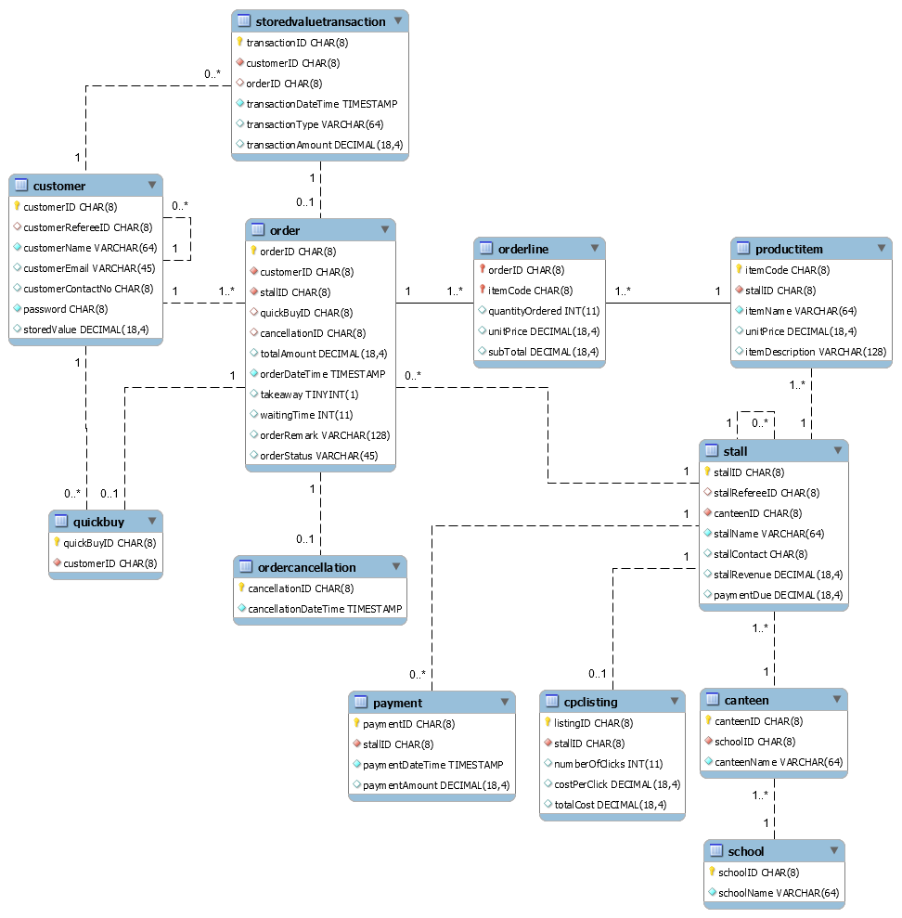

Figure 9.0: NoQ’s database tables and their relationships created using MySQL Workbench

(description with reference to functionality of our app)

## 9.1 NoQ Consumer

Our consumer app allows the consumers to browse through the stall’s menu and directly order through the app using their NoQ credits. When they first download the app, we will present a slideshow to teach them how to use our app (refer to figure 9.1.1).

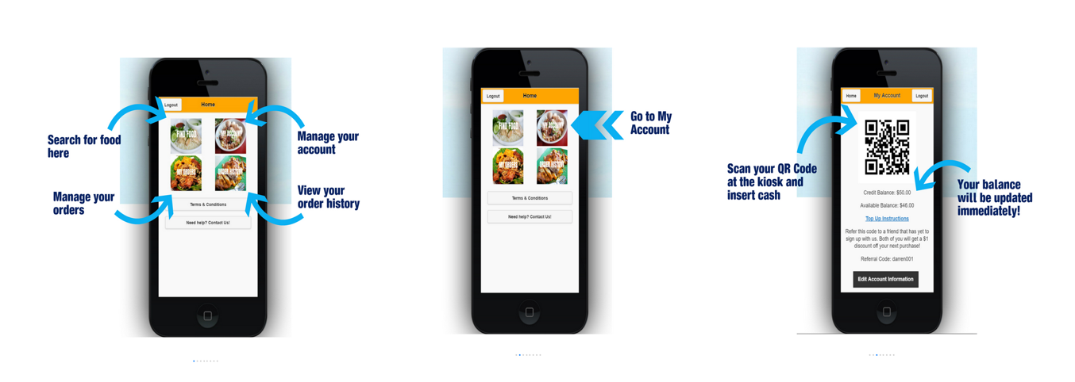

*Figure 9.1.1 Photo Gallery to introduce the app to new consumers*

We will then require each consumer to register for an account with us before they can start using our services (figure 9.1.2). Each consumer is represented by the ‘consumer’ table in the databse, which also stores their account details. They can choose to browse the menu either by rank or according to the different canteen (figure 9.1.3). The listings with the red words featured are for vendors who paid to have their pages listed on the rank page.

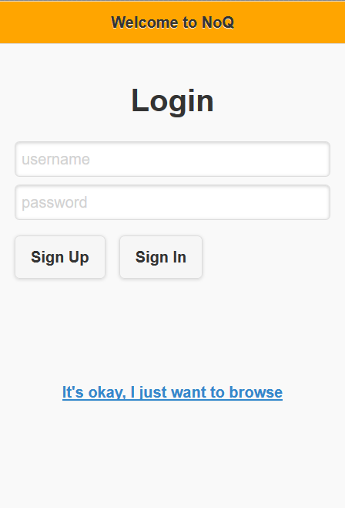

*Figure 9.1.2 Sign up and Sign in page*

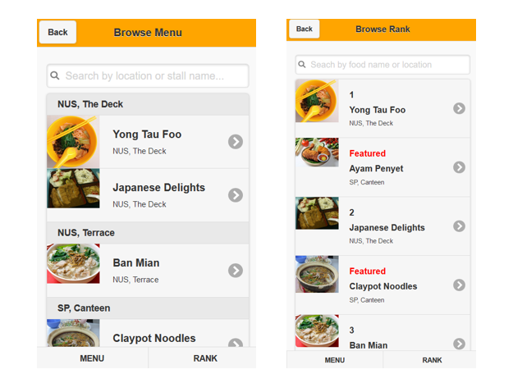

*Figure 9.1.3 View menu page - either categorized by the dfferent canteens or sorted by rank*

Upon signing in, they will be brought to their homepage (Figure 9.1.4), where they can order their food, view order history, manage their account, among other services.

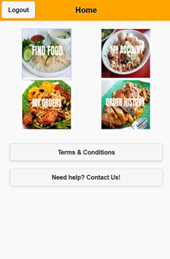

*Figure 9.1.4 Home Page*

### 9.1.1 To Order Food

Click on Find Food (Figure 9.1.5) and users can browse through the menu available. There will be options that allows them to choose the takeaway option and leave special requests for their orders as well. Upon clicking “Add to Order”, there will be a pop-up as to whether they want to save the order into a QuickBuy option. This QuickBuy feature allows users to order their frequently ordered food items easily. This makes it more convenient for them the next time they use our app to order. The QuickBuy option is reflected by the ‘quickbuy’ table in the database. They will then be redirected to the My Orders page (Figure 9.1.6). The red colored dot on the left of the order listing will turn green when the other is ready. Users will then receive a notification to go collect their food.

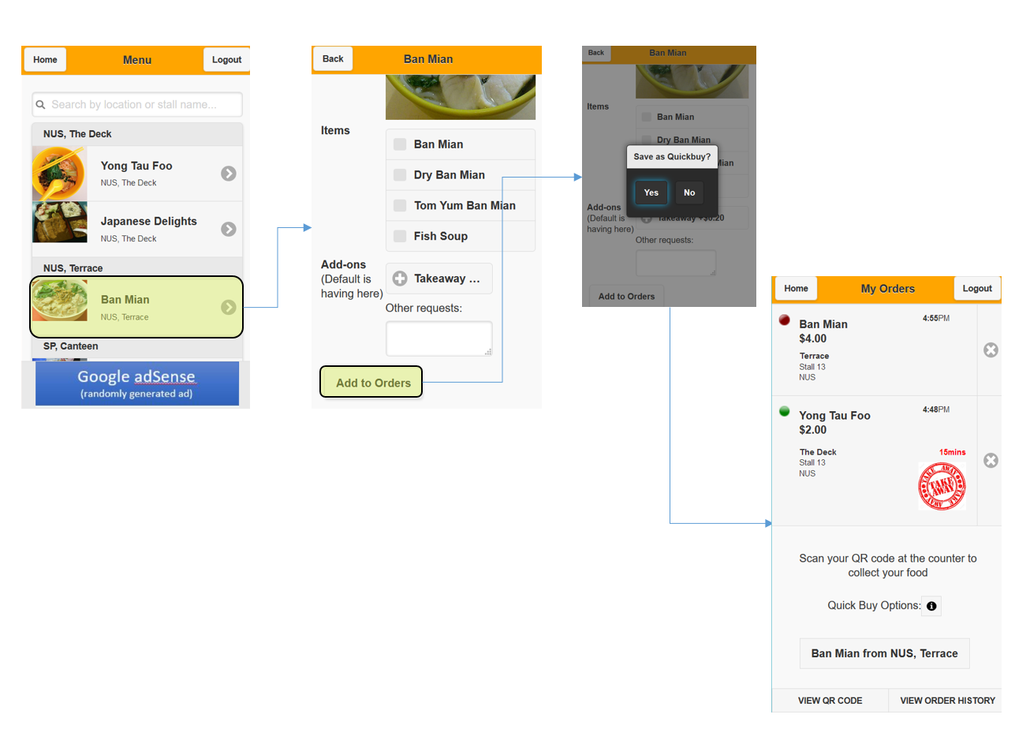

*Figure 9.1.5 Diagram showing how users can order their food*

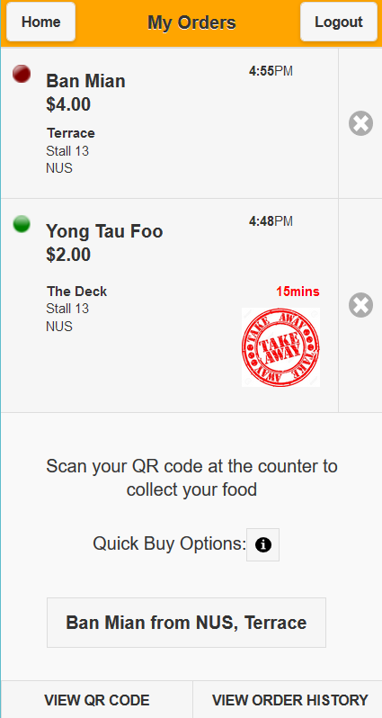

*Figure 9.1.6 Order Page*

They can view their Order History (Figure 9.1.7) via the button at the bottom of the My Orders Page or via the Home page. On the database, each order is represented by the ‘order’ table, where each order consists of at least one ‘orderline’, and each line contains one ‘productitem’. Any order cancellations will be reflected under ‘ordercancellation’.

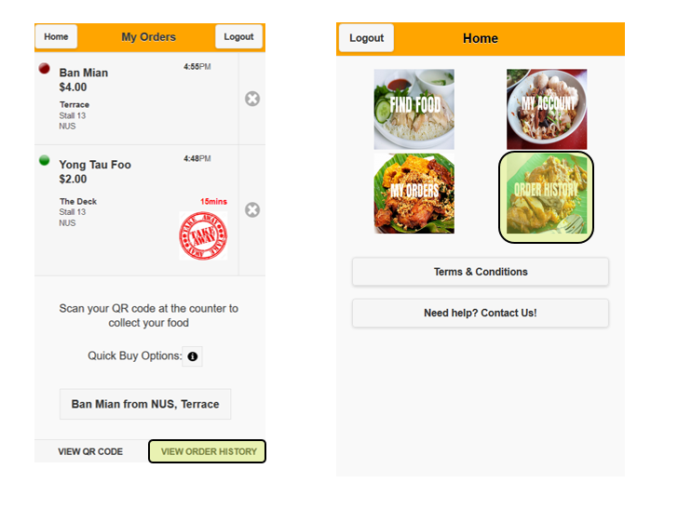

*Figure 9.1.7 Methods to view their Order History is highlighted in yellow*

### 9.1.2 To View E-Wallet and Edit Account Information

My Account allows the user to view the amount of NoQ credits left in his/her e-Wallet. Any top-up transactions will be stored under the ‘storedvaluetransaction’ table in the database, which also accounts for order payment transactions. Top ups can be done at any NoQ kiosk at all participating canteens. This page also allows for the user to edit his/her account information (Figure 9.1.8).

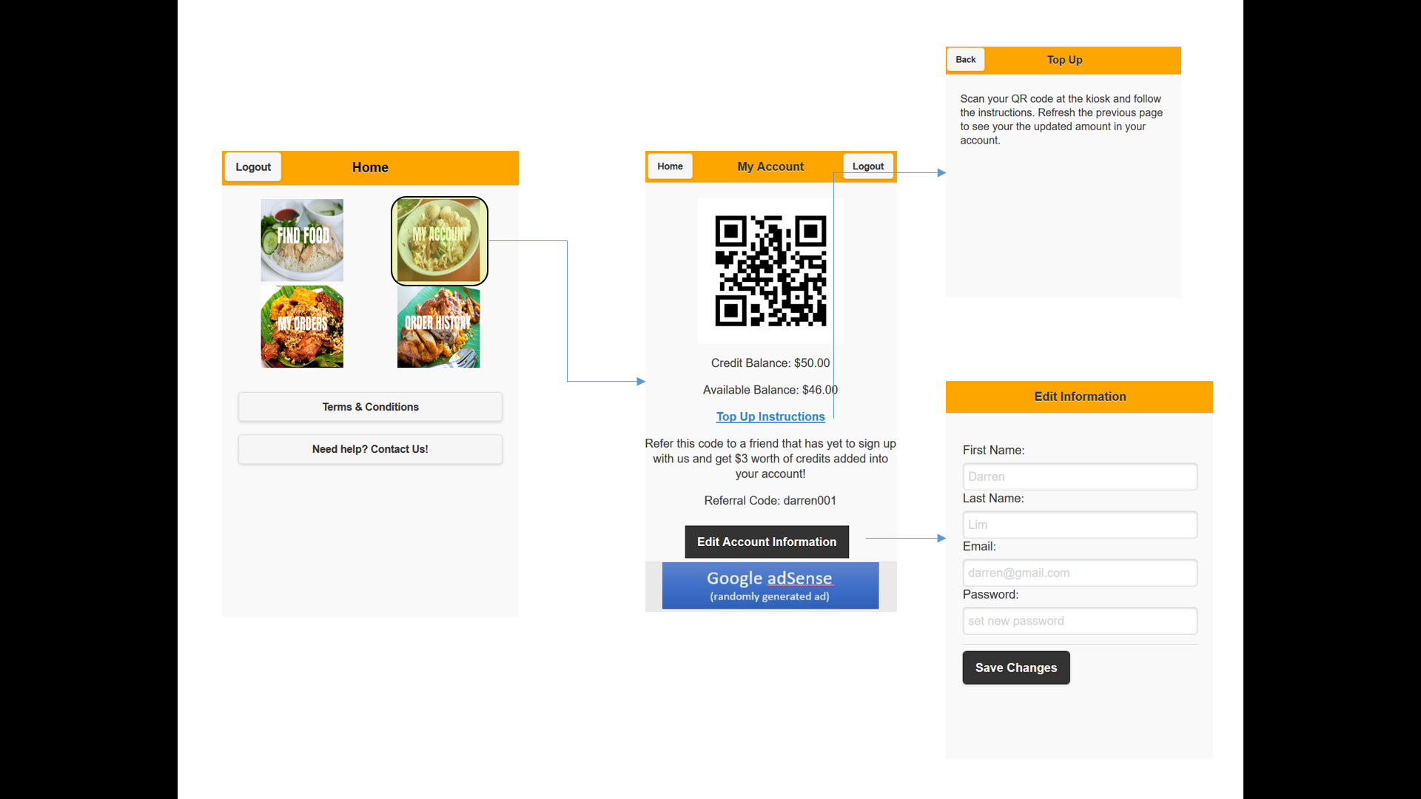

*Figure 9.1.8 My Account page and her features*

### 9.1.3 Other Features of the Home Page

There are two additional buttons at the bottom of the home page, *Terms & Conditions* and *Need Help? Contact Us!* (Figure 9.1.8). This give interested users a better understanding of our policies and app. It also provides a platform for users to leave their feedback.

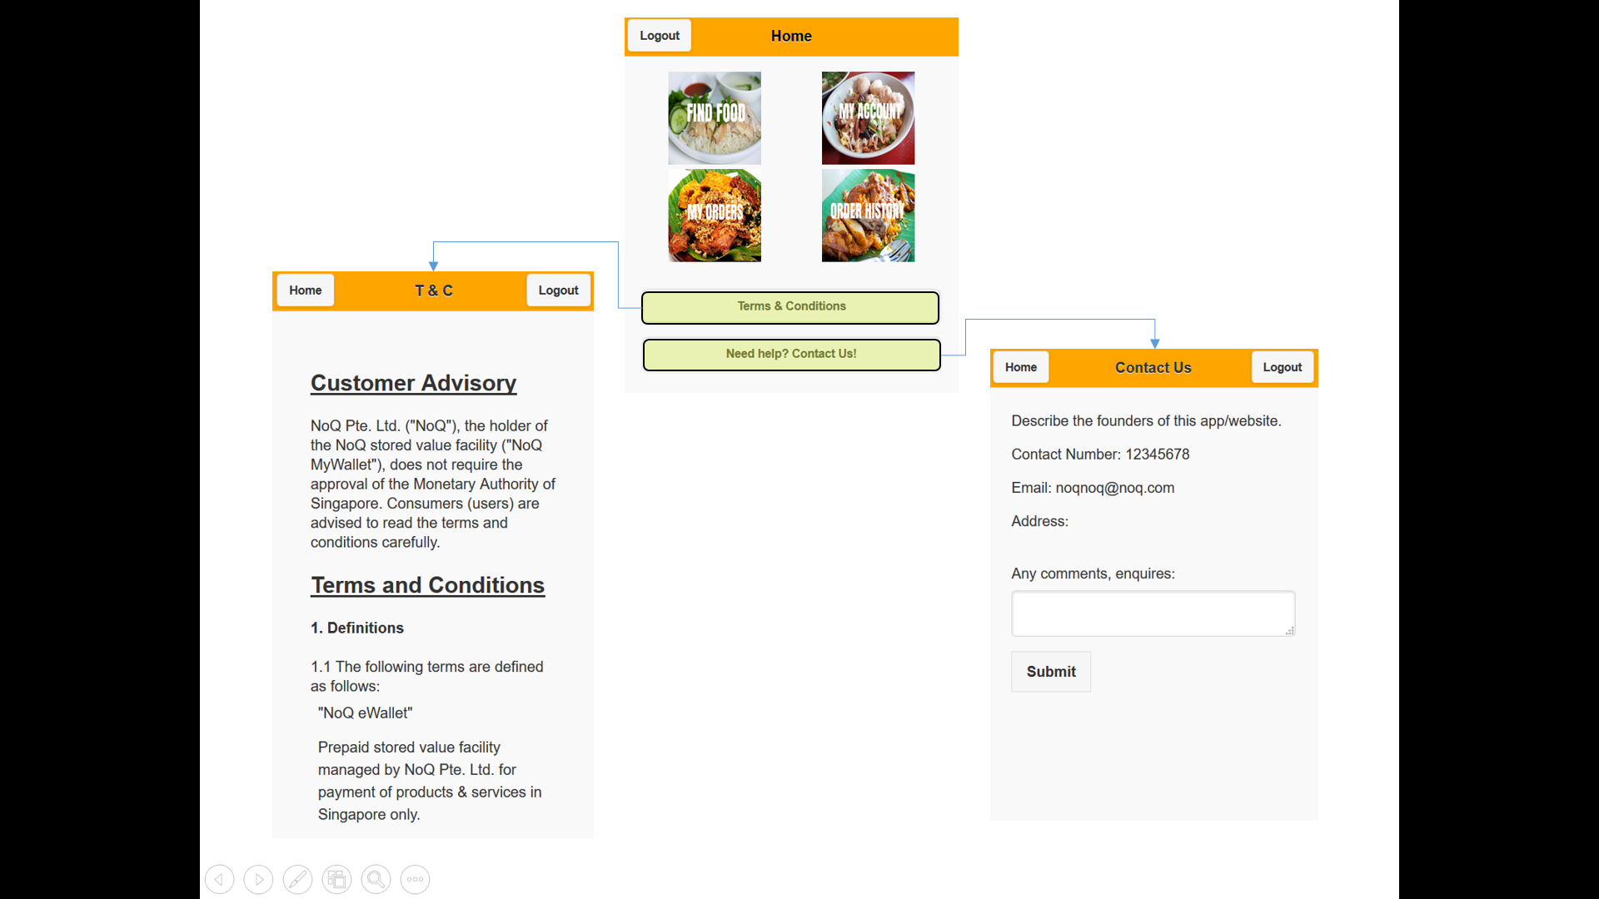

*Figure 9.1.9 Terms & Conditions and Need help? Contact us!*

## 9.2 NoQ Seller

Our seller app allows our canteen vendors to accept and verify that the orders belong to the respective customers. Each vendor will be given an account username and password after they register with NoQ, which they will use to sign in to the app. Each vendor is represented by the ‘stall’ table in the database, which stores all information about the vendor. They can access the app through the loaned tablet that will be provided by NoQ. During the setup of the tablets at the stall, the vendors would be given a short tutorial on how to use the app. Hence there is no slideshow that describes the features of the app, unlike the consumer app.

The start page of the app requires the vendor to sign in with her/her given account username and password. They can also choose to browse the same menu that will be provided to the consumers. Upon sign in, they will be redirected to their home page (Figure 9.2.1)

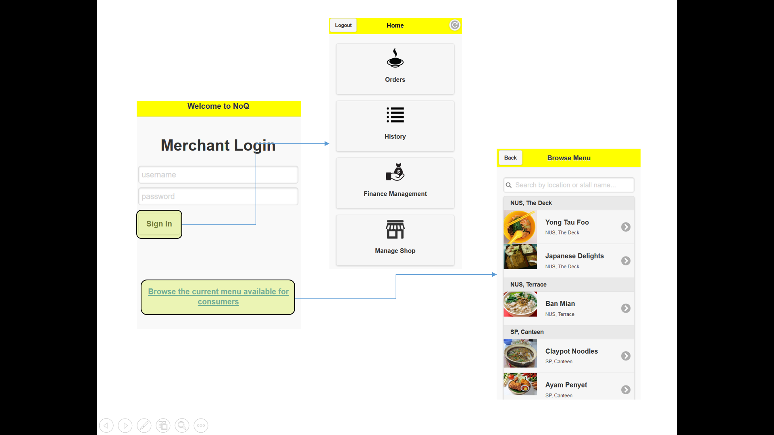

*Figure 9.2.1 Upon sign in into the seller’s app*

### 9.2.1 Orders

The home page will auto-refresh itself every 10 seconds to check if there are new orders. The number of outstanding orders will be reflected in red at the Order button. The vendor’s orders are also represented by the ‘order’ table in the database. The vendor can also choose to refresh the homepage by clicking on the refresh button at the top right side on the header. This is illustrated on figure 9.2.2.

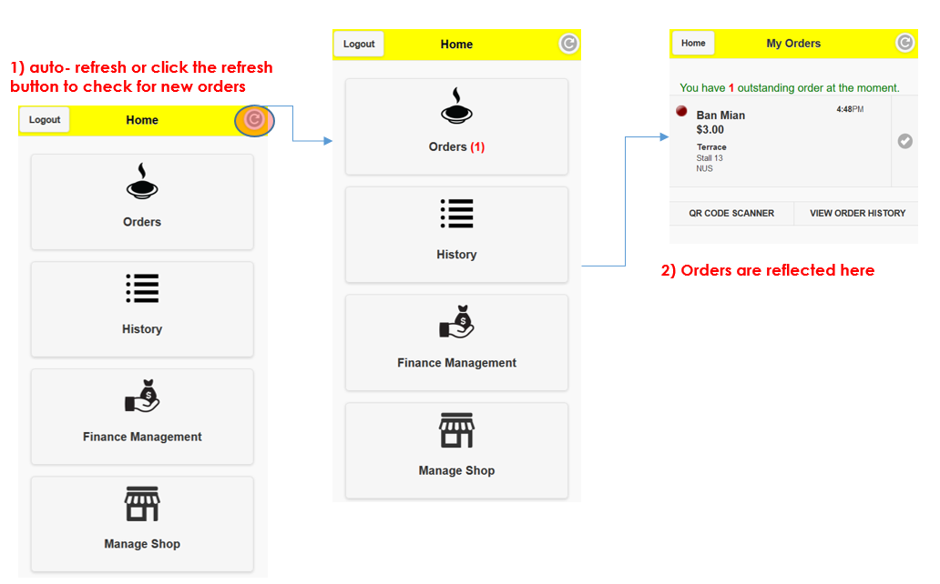

*Figure 9.2.2 Flowchart showing new orders*

Once the vendor have finished preparing the order, he will click the “tick” to notify the customer that the order is ready, illustrated by the green circle in the consumer’s app. A notification will be sent to the customer that the order is ready. When the customer comes to collect his/her order, the vendor will use QR Code Scanner to verify the identity and order of the customer. The order will automatically clear once it has been correctly identified by the QR code scanner. Figure 9.2.3 describes this process.

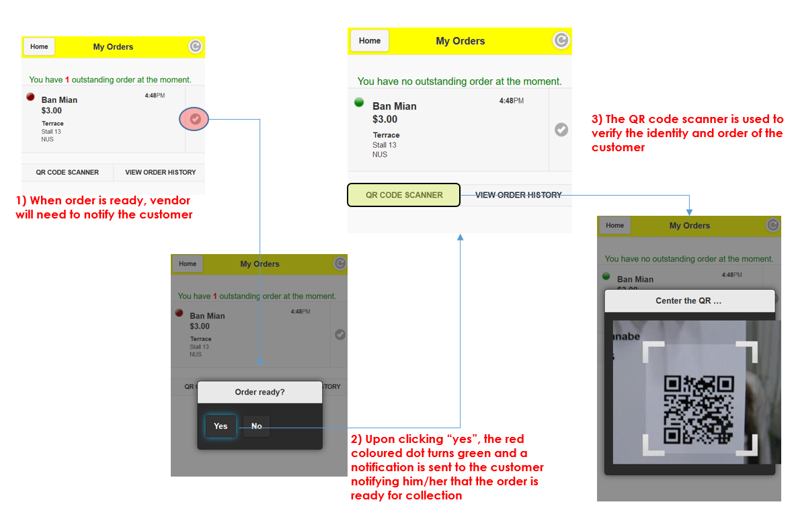

*Figure 9.2.3 Ready Orders*

### 9.2.2 Order History

The order history allows the user to view his past orders (figure 9.2.4).

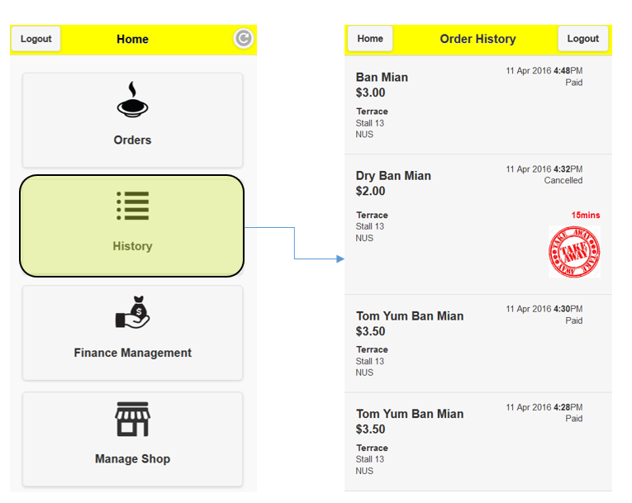

*Figure 9.2.4 Order History*

### 9.2.3 Finance Management

This page will be very informative for the vendors as it provie a quick summary of how much they have earned thus far in that current month (Figure 9.2.5). It also provides them with a breakdown of their sales for the previous months (Figure 9.2.6). This will be auto-generated and will be useful for the vendors to analyze where the bulk of their profits come from. This will assist them in planning the future direction for their shop.

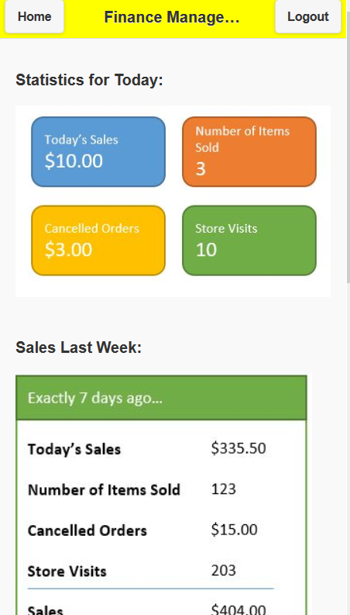

*Figure 9.2.5 Quick sumary of how much they have earned in the today and in the last week*

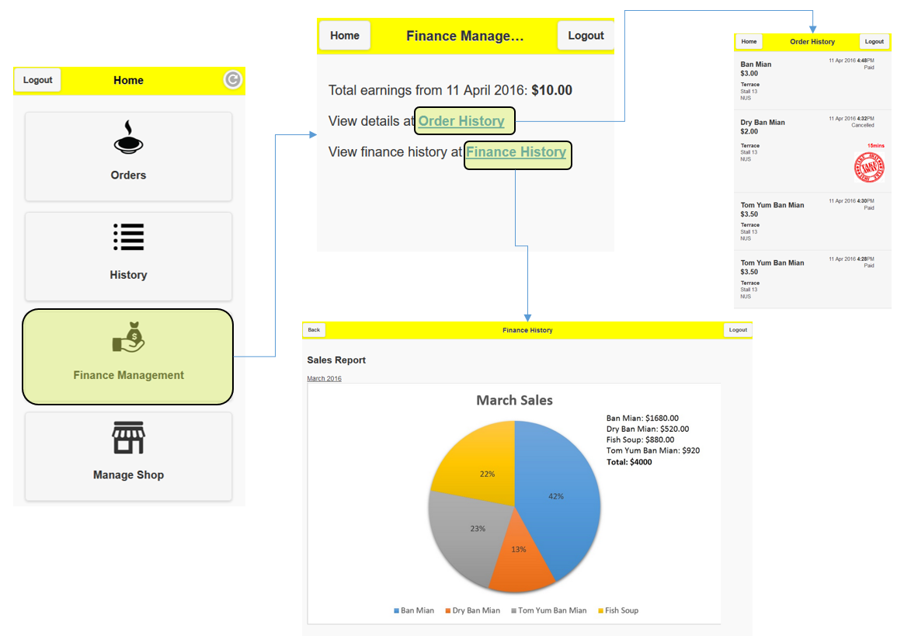

*Figure 9.2.6 Breadown of sales for the previous month*

### 9.2.4 Manage Shop

This page allows the vendors to edit their menu (Figure 9.2.7). They can add new items into the menu. Vendors are also required to check available food items, this helps take into account food items that are out-of-stock.

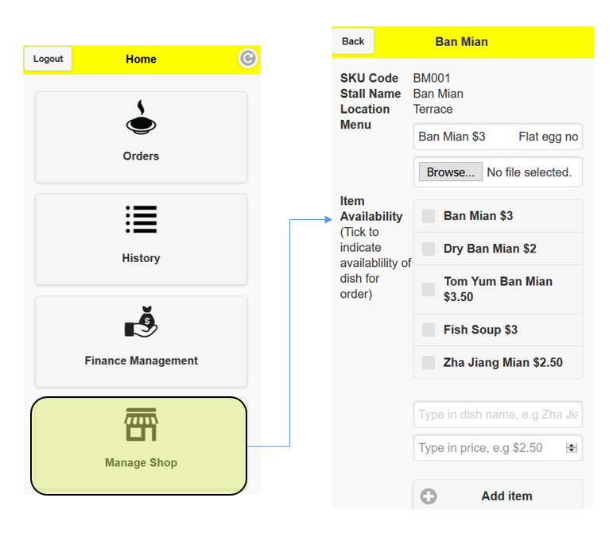

*Figure 9.2.7 Manage Shop*

### 9.2.5 Other Feaures

There are two additional buttons at the bottom of the home page, *Terms & Conditions* and *Need Help? Contact Us!* (Figure 9.1.8). This give interested users a better understanding of our policies and app. It also provides a platform for users to leave their feedback. These are the same as those in the consumer app.

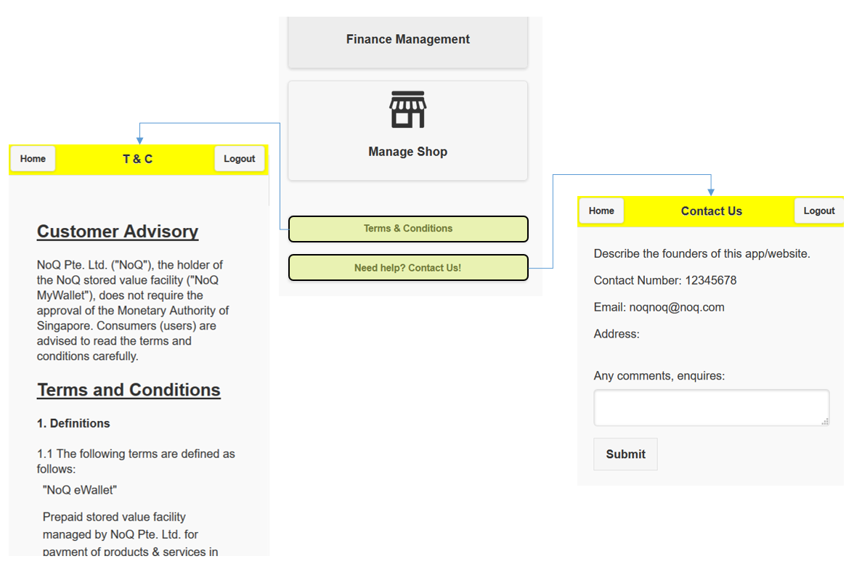

*Figure 9.2.8 Terms & Conditions and Need help? Contact us!*

# 10. Conclusion

In essence, NoQ presents users with the opportunity to commence queueing even without being physically there. As Benjamin Franklin once said, “time is money”. In a society where people are often trying to squeeze out more time, NoQ presents a concept and lifestyle to help time conscious individiuals to save more time. The process of secure payments through stored value credits and the immediate collection of food upon arrival would pose much benefit to our users. With an idea to change the status quo armed with the increasingly popular M-commerce platform, NoQ could be poised for greater success in its demand and may even go on to revolutionize the way we purchase food.

# 11. Future Plans

As a humble start-up, NoQ has little access to more costly resources that would provide improvement for our business. However, if NoQ succeeds on campus, it could potentially revolutionalize the way people queue for and order their food if we expand its reach to other eating places. NoQ’s success would mean the possibility of future enhancements to our services as described below.

## 11.1 Accuracy of Waiting Time

NoQ’s current queueing system involves consumers choosing their preferred collection time, and consumers are notified when their orders are ready. However, as orders are prepared manually by the vendors, there may be discrepancies between the actual collection time and the stipulated collection time, especially during peak hours. Once NoQ has had sufficient order records, we could run data analysis on the waiting time for each vendor to generate a more accurate estimate of the collection time for consumers. This provides a seamless experience for both consumers and vendors as consumers do not need to spend additional time waiting for their orders if it is not yet ready, and vendors will not be overwhelmed by their orders as their customers have already been informed of the waiting time.

## 11. 2 Expand to Restuarants

NoQ can be further expanded to help restaurants, especially those which are very popular and are overwhelmed by long waiting lines. This can be done by modifying our app such that each restuarant has their personal menu, a service that is similar to eMenu tablets that are rising in populariy among restaurants today. We can convince restuarants to take up our app in the bid of going green since our app can be accessed through the phones of both the restaurant owners as their customers, eliminating the need for additional tablets. This way, our app still serves the same purpose while helping restaurant owners save costs in the purchase and mantainence of both the hardware and technology. Our business will also provide them with the technical expertise in their eMenu design and interface. This will in turn provide us with an additional revenue model.

## 11. 3 Wireless Top-Up Services

To increase the convenience for our consumers, we will look into implementing wireless top-up services. We could make use of the Near-Field Communications (NFC) technology in mobile phones to speed up top up and payement transactions. This means that there will be no need for QR scanning and transactions can be done just by tapping their phones on a reader.

In addition, as our business expands and revenue increases, we will be able to afford additional credit card transaction charges and security measures to protect consumer credit card data. Hence, we can work with credit card companies to widen the top-up options, providing greater convenience for our customers.

## 11. 4 Collaborations with other industry related businesses

With several concepts of food ordering an queueing in today’s market, NoQ can partner related businesses where both parties can leverage on each other’s strengths and cover each other’s loopholes. For instance, NoQ can partner delivery services, providing a one-stop service that covers all modes of food consumption (i.e. delivery, takeaway, and dining-in). With the partnership, we will no longer be indirect competitors of each other, bringing both companies greater advantage in this competitive growing market.

In the same manner, we can also collaborate with other services such as restaurant reservation application Chope or queueing systems appliciation TickTok. NoQ can benefit from their wide network range of restaurants, while providing our partners with additional dimensions to their services (i.e. payment and ordering systems). This would provide a more seamless experience for users.

# 

# 

## 

## References

2016. *Play.google.com*, (available at https://play.google.com/store/apps/details?id=sg.novustol.beveat&hl=en; retrieved April 17, 2016).

"Carousell | Press Page",. 2015. *Carousell.totemapp.com*, (available at http://carousell.totemapp.com/team; retrieved April 17, 2016).

Franklin, B. 1762. *Advice to a young tradesman*, [Boston]: (Sold [by Benjamin Mecom] at the new printing-office, in Boston.).

"Google study: Singapore is world's top smartphone market per capita - Mumbrella Asia",. 2014.*Mumbrella Asia*, (available at http://www.mumbrella.asia/2014/10/google-study-singapore-worlds-top-smartphone-market-per-capita/; retrieved April 17, 2016).

"More players jumping on the food delivery wagon",. 2016. *AsiaOne*, (available at http://news.asiaone.com/news/singapore/more-players-jumping-food-delivery-wagon; retrieved April 17, 2016).

"Productivity and Innovation Credit Scheme - IRAS",. 2016. *Iras.gov.sg*, (available at https://www.iras.gov.sg/irashome/Schemes/Businesses/Productivity-and-Innovation-Credit-Scheme/; retrieved April 17, 2016).

Seward, Z. 2016. "GrubHub and Seamless take a 13.5% cut of their average delivery order", *Quartz*, (available at http://qz.com/182961/grubhub-and-seamless-take-a-13-5-cut-of-their-average-delivery-order/; retrieved April 17, 2016).

"Smartphone penetration in Singapore the highest globally: Survey",. 2016. *TODAYonline*, (available at http://www.todayonline.com/singapore/smartphone-penetration-singapore-highest-globally-survey; retrieved April 17, 2016).